ANALYSIS OF LIQUIDITY, SOLVABILITY, ACTIVITY, AND PROFITABILITY RATIOS TO MEASURE FINANCIAL PERFORMANCE AT PT. NUSANTARA PELABUHAN HANDAL, TBK FOR THE PERIOD 2015-2024
Revista Ayunda Putri¹

¹Fakultas Ekonomi dan Bisnis, Universitas Pamulang, Tangerang Selatan
e-mail: revistaayndp19@gmail.com

Abstract

This study aims to evaluate the financial performance of PT Nusantara Pelabuhan Handal Tbk for the 2015–2024 period using Liquidity, Solvency, Activity, and Profitability ratios. The research adopts a quantitative descriptive method and uses secondary, time series data obtained from the company’s financial statements available on the Nusantara Port website. The findings show that the company’s liquidity position is generally unhealthy. The average Current Ratio (163.6%) and Quick Ratio (123.3%) are below industry standards of 200% and 150%. Only the Cash Ratio (63.8%) exceeds the benchmark of 50%. The solvency condition is also weak, with a Debt to Asset Ratio of 57.3% (industry standard 35%) and a very high Debt to Equity Ratio of 464.6% (standard 90%). Activity ratios indicate poor operational efficiency. Total Asset Turnover (0.02 times) and Fixed Asset Turnover (0.03 times) are far below their industry standards of 2 times and 5 times. Profitability ratios also show unhealthy performance: Gross Profit Margin (26.8%), Net Profit Margin (–1.3%), Return on Assets (–0.6%), and Return on Equity (23.7%) all fall short of the required industry benchmarks.

Keywords: Liquidity Ratios; Solvency Ratios; Activity Ratios; Profitability Ratios; Financial Performance

Introduction
Financial ratio analysis is a tool used to evaluate a company’s performance by comparing items in its financial statements, which include the Balance Sheet, Income Statement, Cash Flow Statement, Statement of Changes in Equity, and Notes to the Financial Statements. These reports present key information on assets, liabilities, revenues, expenses, and overall financial condition, allowing companies to assess and analyze their financial health.
The main purpose of financial ratio analysis is to estimate and predict a company’s future financial condition as accurately as possible, as well as to evaluate its performance based on existing financial data. PT Nusantara Pelabuhan Handal Tbk (NPH) is a company engaged in container terminal management, operating in Tanjung Priok and Bangkok while providing services such as terminal operations, equipment provision, logistics, and digital port solutions. Its business spans domestic and international markets, including Southeast Asia, the Middle East, and Europe.
Given its broad operations, NPH must analyze its financial statements to understand its financial development and determine whether performance is improving or declining. The analysis uses four key financial ratios: Liquidity (company’s ability to meet short-term obligations), Solvency (ability to pay long-term and short-term debts), Activity (efficiency in using assets), and Profitability (ability to generate profits).
Based on this background, the author chose the title “Analysis of Liquidity, Solvency, Activity, and Profitability Ratios to Measure Financial Performance at PT Nusantara Pelabuhan Handal Tbk for the Period 2015–2024” as the focus of this assignment.

Theoretical Framework
Financial ratio analysis using a quantitative approach is used to assess a company's financial performance objectively and measurably. Each ratio reflects a specific aspect of a company's ability to manage its assets, liabilities, and capital to achieve optimal profitability. According to Brigham and Houston (2019), financial ratio analysis is a key tool in assessing a company's efficiency, liquidity, solvency, and profitability, which serve as the basis for financial decision-making.
A literature review shows a significant relationship between financial ratios and company's profitability. Kasmir (2022) states that a high level of liquidity does not always indicate good financial conditions because excess current assets can reduce investment effectiveness. Hidayat (2022) found that an optimal solvency ratio has a positive effect on profitability because controlled debt can increase profits through the leverage effect. Meanwhile, Tambunan (2021) explains that activity efficiency, as measured by Total Asset Turnover (TATO) and Fixed Asset Turnover (FATO), plays an important role in increasing a company's revenue and net profit, especially in the port and logistics sector.
However, most previous studies are still descriptive in nature and have not empirically tested the relationship between variables using a long-term quantitative approach. In addition, the capital-intensive nature of the port industry causes activity ratios to tend to be low, while profit margins are often thin due to high operating costs. This condition creates a research gap that needs to be addressed through a quantitative approach to measure the effect of financial ratios on the profitability of national port companies.
This study is based on three main theories in financial management, namely:
- Trade-Off Theory, This theory explains that companies must balance risk and return in managing assets and debt. Excessive liquidity reduces the risk of default, but can decrease profitability because idle funds are unproductive.
- Capital Structure Theory, Based on the Pecking Order Theory and Trade-Off Theory, moderate use of debt can increase profitability through the leverage effect, but excessive use can lead to high financial risk.
- Operational Efficiency Theory, This theory emphasizes the importance of efficiency in the use of fixed assets and total assets to generate sales. The Total Asset Turnover (TATO) and Fixed Asset Turnover (FATO) ratios are the main indicators in measuring this level of efficiency. Based on the above theory and literature review, the relationship between variables in this study can be explained quantitatively as follows:
- X₁ = Liquidity Ratio (Cash Ratio, Quick Ratio, Current Ratio)
- X₂ = Solvency Ratio (Debt to Asset Ratio, Debt to Equity Ratio)
- X₃ = Activity Ratio (Total Asset Turnover / TATO, Fixed Asset Turnover / FATO)
- Y = Profitability Ratio (Gross Profit Margin / GPM, Net Profit Margin / NPM, Return on Assets / ROA, Return on Equity / ROE)
The three independent variables (X₁, X₂, X₃) are assumed to have an effect on the dependent variable (Y), both partially and simultaneously. Thus, this study assesses the relationship between financial variables empirically based on company financial statement data. Based on previous theories and empirical studies, the hypotheses proposed in this study are as follows:
- H₁: Liquidity ratio has a negative effect on profitability.
- H₂: Solvency ratio has a positive effect on profitability.
- H₃: Activity ratio has a positive effect on profitability.
- H₄: Liquidity, solvency, and activity ratios simultaneously have a significant effect on profitability.
Thus, the theoretical framework of this study confirms that a company's financial performance can be explained quantitatively through the influence of liquidity, solvency, and activity ratios on profitability. This study is expected to contribute scientifically to the development of financial management literature and provide practical implications for improving the efficiency and competitiveness of national port companies.
Method
The operationalization of research variables is the transformation of abstract concepts into variables that can be measured or observed empirically in the context of research. This requires a clear definition of variables and the establishment of specific indicators to measure them. Sugiyono (2017) states that the operationalization of research variables is a way of measuring abstract concepts or variables so that they become variables that can be measured and observed. According to Sugiarto (2016:38), the operationalization of research variables is a complete set of instructions on what to observe and measure a variable or concept in order to test its perfection. Operational variables are found in items included in the research instrument.
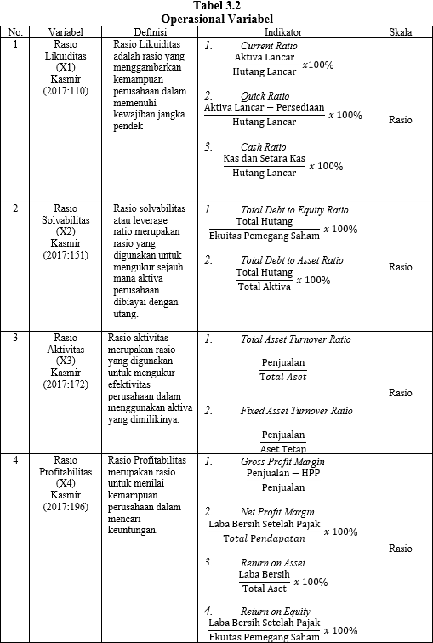
As can be seen from the expert opinion above, research variable operations are an important process in research that aims to transform abstract concepts into variables that can be measured or observed empirically. This requires a clear definition of variables, identification of appropriate indicators, development of valid and reliable measurement tools, and ensuring that the measurements reflect the concepts to be measured by the research.
According to Sugiyono (2017), data collection methods are techniques used by researchers to obtain accurate and valid data to answer research questions. The selection of appropriate data collection methods will affect the quality and accuracy of the data obtained in the study.
In obtaining data for this research, it is necessary to conduct a data collection process consisting of information received by the author in both verbal and written forms. Therefore, the author uses several data collection methods that are relevant to the analysis of the problem, namely:
- Library Research Techniques, This technique is intended to collect sources from various books, journals, and thesis references. These are then used to assist in analyzing, finding references, drawing conclusions, and making suggestions.
- Internet Research Techniques, This research is used to find sources that may not be available in the library also collects important data sources related to the research variables and collects data on the companies being studied, such as written reports obtained from companies in the form of financial reports of PT. Nasional Pelabuhan Handal Tbk. listed on Nasional Port for 2015-2024, obtained from the official website of NPH https://nusantaraport.id.
The data analysis technique used by the author in this study is descriptive analysis. According to Juliandi, Irfan, and Manurung (2015:86), descriptive means analyzing data to summarize and describe numerical data so that it is easy to interpret. Arikunto (2017): Data analysis techniques are a way to extract and process data obtained from research with the aim of finding the facts and information needed. Sugiyono (2017): Data analysis techniques are the process of processing and interpreting data obtained from data collection with the aim of answering research questions.
In this case, the author looks at the company's financial statement data in the balance sheet and income statement. The steps taken by the author are as follows:
- Collect financial data, namely balance sheets and income statements for the period 2015-2024.
- Calculate financial ratios using the four ratios.
- Analyze financial performance using the company's liquidity, solvency, profitability, and activity ratios.
- Draw conclusions about the financial performance of PT Nasional Pelabuhan Handal Tbk based on financial ratios.
The company's financial performance will be compared with the industry standards of similar companies by taking the following steps (Munawir, 2002: 67):
- Collecting financial reports from companies similar to the company being compared.
- Calculating the liquidity, activity, solvency, and profitability levels of PT. Nasional Pelabuhan Handal for the period 2015-2024.
Result
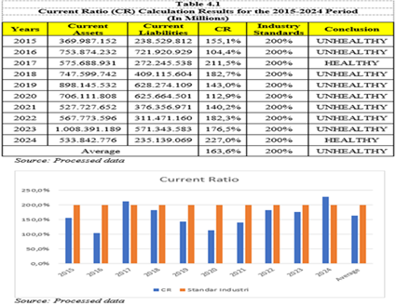
- Liquidity Ratio
Based on the data processed above, it can be explained that the results of the liquidity ratio calculation at PT Nasional Pelabuhan Handal Tbk for the 2015-2024 period, which was processed using the Current Ratio above, experienced fluctuations but tended to be below industry standards. The overall average for the year was 163.6%, while the industry standard for a healthy Current Ratio is 200%. This shows that the company is able to guarantee that every Rp. 1.00 of current liabilities is covered by current assets of Rp. 1.63.
In 2015, PT Nasional Pelabuhan Handal's Current Ratio was 155.1%. This means that every Rp. 1 of current liabilities is covered by current assets of Rp. 1.5. Based on this value, it can be stated that the company is not healthy, due to its sufficient current assets, but also very high current liabilities, so that it is not can meet the specified industry standard of 200%.
As seen in the calculations and graphs in Table 4.1 above, from 2016 to 2024, the Current Ratio calculations fluctuated, but were still below the industry standard, even though they met the standard in 2017 and 2024. This indicates that the Current Ratio at PT Nasional Pelabuhan Handal is still considered unhealthy, meaning the company has not been able to manage its current assets or pay its debts effectively.
- Quick Ratio
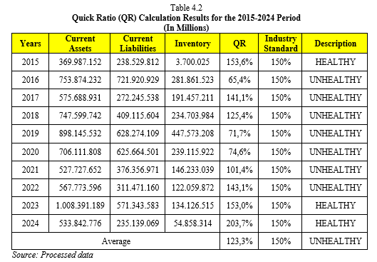
Based on the results of Table 4.2 above, it can be seen that the liquidity ratio of PT Nasional Pelabuhan Handal Tbk, as measured by the Quick Ratio, has fluctuated. In 2015, PT Nasional Pelabuhan Handal Tbk's Quick Ratio was 153.6%, which was obtained by subtracting inventory from current assets and comparing it with the value of current liabilities. This means that the company has current assets of 1.53 times its total current liabilities, or in other words, every Rp. 1.00 of current liabilities is guaranteed by Rp. 1.53 of current assets.
In the following years, the Quick Ratio obtained by PT Nasional Pelabuhan Handal Tbk experienced increases and decreases, but the Quick Ratio value was still below the industry standard of 150%, even though in 2023 and 2024 it reached the industry standard. Looking at the overall average for the year, which was 123.3%, it can be said that the Quick Ratio at PT Nasional Pelabuhan Handal for the 2015-2024 period was not healthy, whereas the industry standard for a company's Quick Ratio to be considered healthy is 150%. This indicates that the company is able to guarantee that every Rp. 1.00 in current liabilities can be covered by current assets of Rp. 1.23. This also means that the company has not been optimal in fulfilling its current liabilities.

- Cash Ratio
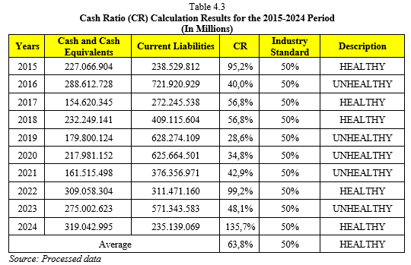
From the calculation data above, it can be explained that the Cash Ratio calculation results at PT Nasional Pelabuhan Handal Tbk for the period 2015 to 2024 experienced fluctuations.
In 2015, the Cash Ratio calculation result for PT Nasional Pelabuhan Handal was 95.2%. This means that for every Rp. 1.00 in current liabilities, Rp. 0.95 in cash and cash equivalents is available to cover it. Then, in the following years, in 2016, it decreased by 55.2% to 40.0%, which did not meet industry standards and was considered unhealthy.
In 2018, PT Nasional Pelabuhan Handal Tbk's Cash Ratio increased to 56.8%. This means that for every Rp. 1.00 in current liabilities, Rp. 0.56 in cash and cash equivalents are available. This year, the company was declared healthy in terms of Cash Ratio, as it exceeded the industry standard of 50%. However, in the following year, PT Nasional Pelabuhan Handal Tbk's Cash Ratio declined again from 56.8% to 28.6% in 2019, where the company's Cash Ratio was once again deemed unhealthy as it still did not meet the industry standard.
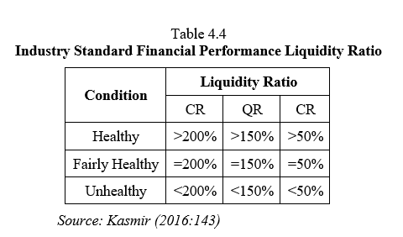
In 2022, PT Nasional Pelabuhan Handal Tbk's cash ratio increased significantly to 99.2%. This means that for every Rp. 1.00 in current liabilities, Rp. 0.99 is secured by cash and cash equivalents. This year, the company is considered healthy in terms of cash ratio, as it exceeds the industry standard of 50%. However, in the following year, PT Nasional Pelabuhan Handal Tbk's Cash Ratio declined again from 99.2% to 48.1% in 2023, which meant that the company's Cash Ratio was once again considered unhealthy because it was still insufficient to meet industry standards. However, in 2024, it increased significantly again to 135.7%. This means that for every Rp. 1.00 in current liabilities, there is Rp. 1.35 in cash and cash equivalents. This year, the company is considered healthy in terms of its cash ratio, as it exceeds the industry standard by 50%. Looking at the overall average for the year, which was 63.8% and deemed healthy, the company was able to exceed the industry standard for a company's cash ratio, which is 50%.

- Solvency Ratio
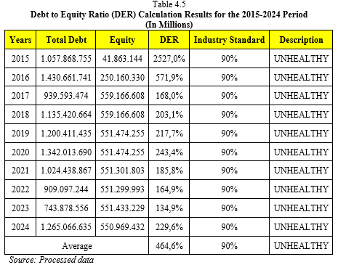
This ratio measures how companies pay their obligations using the equity owned by the company. Based on the calculation of the data in the table above, the Debt to Equity Ratio in the 2015-2024 period fluctuated.
In 2016, the company's Debt to Equity Ratio decreased by 1,955.1% to 571.9%. This indicates that for every Rp. 0.571 of total debt, there is Rp. 1 of total company equity. The company's total debt is 571.9% of the company's total equity. This means that the company's funding sources are more from equity than from debt.
Based on the Debt to Equity Ratio calculation in the table above, it can be seen that the Debt to Equity Ratio at PT Nasional Pelabuhan Handal Tbk is unhealthy, based on industry standards, where a Debt to Equity Ratio value of 90% or less is considered healthy or good. The average Debt to Equity Ratio at PT Nasional Pelabuhan Handal Tbk for the 2015-2024 period is 464.6%, which is above 90%. The higher this ratio, the higher the risk.
The Debt to Asset Ratio is the percentage ratio of total debt to total assets. The higher the DAR value, the more debt is used to purchase company assets, making the company more risky. The industry standard for the Debt to Asset Ratio itself is 35%, which is considered good or healthy.
As seen in Table 4.5, the Debt to Asset Ratio of 57.3% is considered unhealthy. When viewed on an annual basis, from 2015 to 2024, the company's DAR was classified as unhealthy because it was above the industry standard. However, in 2023, the company's DAR decreased by 6.5% from 2022 to 43.2% in 2023, which is still classified as unhealthy.
Based on the company's average Debt to Asset Ratio, the company is at a level where it manages its assets using its debt poorly. The higher the Debt to Asset Ratio is above the industry standard, the more inefficient the company's asset management is, which means the company's performance is getting worse.
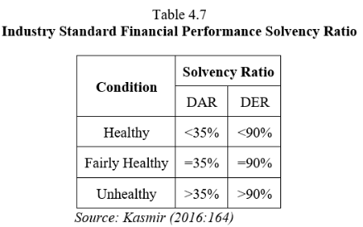

- Activity Ratio
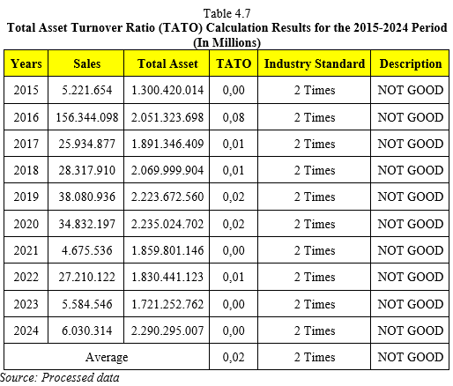
Based on the calculations in the table above, the Total Asset Turnover Ratio at PT Nasional Pelabuhan Handal Tbk for the 2015-2024 period fluctuated, with the company's highest TATO ratio amounting to 0.08 times in 2016. A higher ratio indicates better company performance and financial health; however, PT Nasional Pelabuhan Handal Tbk has not yet met the industry standard of 2 times.
When broken down, from 2017 to 2024, there was a decline from 0.08 times to 0.00 times. This figure was calculated by dividing sales by total assets, which was due to a decline in sales in 2017.
Based on the overall average results from 2015 to 2024, PT Nasional Pelabuhan Handal Tbk's TATO ratio is 0.02, which is still below the industry standard of 2 times, so it cannot be considered healthy.
Based on the table above, the Fixed Asset Turnover Ratio at PT Nasional Pelabuhan Handal Tbk fluctuated between 2015 and 2024, with the company's highest FATO ratio being 0.12 times in 2016. The higher this ratio, the better the company's financial performance.
The FATO ratio in 2017 was 0.02 times, a decrease of 0.1 times compared to 2016, which was 0.12 times. This decline was due to a decrease in sales in 2017 compared to 2016.
The company's FATO ratio in 2018 remained at 0.02 times, the same as in 2017, with no decrease or increase. Then in 2019, the company's FATO ratio increased by 0.01 times to 0.03 times compared to 2018, which was 0.02 times. This increase was due to an increase in the company's sales value in 2019.
In 2024, the company's FATO ratio experienced a significant decrease from 0.03 times in 2019 to 0.00 times. This was also due to the onset of the pandemic and the company's sales declining rapidly in 2019 from IDR 38,080,936 to IDR 6,030,314 (in millions) in 2024. This indicates that the FATO condition in 2024 can be considered unhealthy because the company has not met the industry standard of more than 5 times.
It can be concluded that the average FATO ratio of PT Nasional Pelabuhan Handal Tbk from 2015 to 2024 is 0.03 times. This means that during the period from 2015 to 2024, the company cannot be considered healthy or good because the overall average FATO ratio for 2015-2024 still does not meet the industry standard, which is 5 times.
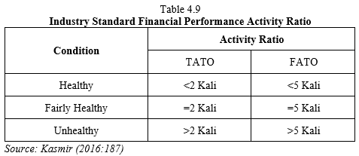

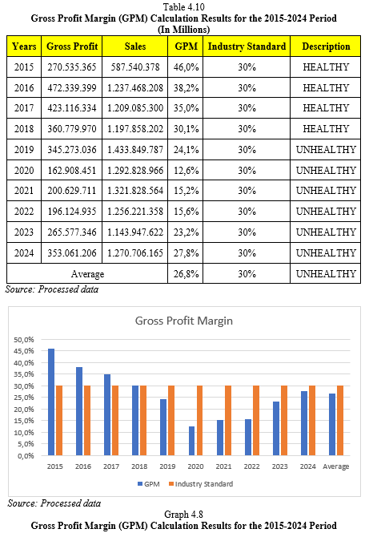
- Profitability Ratio
Looking at the Gross Profit Margin calculation table above, it can be seen that the company experienced fluctuations in this ratio, with the highest GPM ratio being in 2015 at 46.0%. With this value, the company can be said to be healthy because it is above the industry standard value of 30%.
When looking at the GPM ratio in 2019, there was a drastic decline of 21.9% compared to 2015. In 2019, there was a decline from 46.0% to 24.1% due to differences in sales revenue, which is closely related to the company's cost of sales, resulting in less efficient company operations.
Looking at the initial decline in 2019. In fact, this figure decreased significantly between 2020 and 2022 by 8.5%, to 15.6% in 2022, because in 2020-2022 the economy in Indonesia did not perform well due to the COVID-19 pandemic, coupled with the fact that producers had few buyers at that time, which caused a decline in sales in 2020.
In 2024, the company's GPM index increased again by 12.2% compared to 2022, reaching 27.8%. This was due to an increase in sales value, which was possible because the pandemic had ended.
Judging from the overall average GPM ratio from 2015 to 2024 at PT Nasional Pelabuhan Handal Tbk of 26.8%, it means that the company in that period can be considered healthy or good in terms of Gross Profit Margin ratio because it is above the industry standard value of 30%.
As can be seen from the table and graph above, in 2015 it was -8.6%, then in 2016 there was an increase from -8.6% to 7.6%. This increase occurred because the company's revenue increased and net profit after tax also increased slightly. In 2018, the company's net profit margin declined again from 11.1% to -3.5%. This means that every Rp. 1 of sales is guaranteed by a net profit after tax of Rp. -0.3. This decline occurred because the amount of net profit was lower than its revenue.
Looking at 2021, the company's Net Profit Margin fell significantly from -3.5% to -6.3% in 2018. This was due to a drastic decline in revenue and net profit after tax from the previous year, as well as the COVID-19 pandemic that hit the global economy, particularly in Indonesia, making it very difficult to generate more revenue. This also caused the company's NPM to fall far below the industry standard.
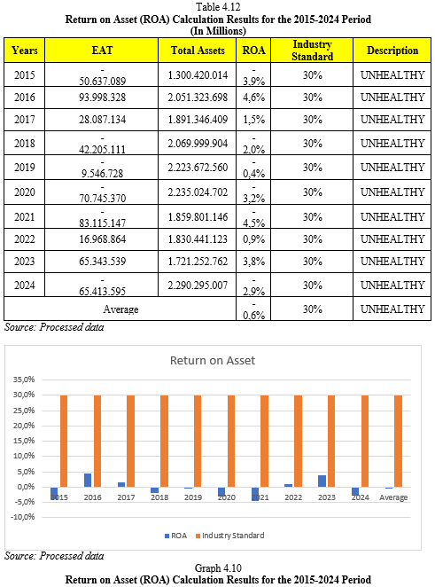
Then in 2023, the company's Net Profit Margin increased again by 12% to 5.7% in 2023, which means that every Rp. 1 of sales is guaranteed by a net profit after tax of Rp. 0.5. This increase was due to an increase in net profit after tax, which was greater in percentage terms than the increase in revenue.
Then in 2024, the company's Net Profit Margin experienced a significant decline of 5.7% from 2023 to -5.1% in 2024. This means that every Rp. 1 of sales is guaranteed by a net profit after tax of Rp. -0.5.
It can be concluded from the overall average results of PT Nasional Pelabuhan Handal Tbk for the 2015-2024 period on the Net Profit Margin, which is -1.3%, that the company cannot yet be considered healthy or good in terms of the NPM ratio because it till cannot meet the industry standard of 20%.
In 2015, PT Nasional Pelabuhan Handal Tbk's Return On Assets was -3.9%, which was still below the industry standard.
Then in 2016, PT Nasional Pelabuhan Handal Tbk's Return on Assets increased by 8.5% compared to 2015, reaching 4.6%. This was due to a slight increase in the company's net profit.
In 2018, PT Nasional Pelabuhan Handal Tbk's Return on Assets decreased from the previous year's 6.6% to -2.0%. This decline still did not meet the company's industry standard.
In 2023, as can be seen in the table and graph above, PT Nasional Pelabuhan Handal Tbk experienced a significant increase in Return on Assets, from 5.8% to 3.8%.
Then in 2024, PT Nasional Pelabuhan Handal's Return on Assets declined again by 6.7% to -2.9% in 2024. This was because the company was not yet mature in planning to overcome the pandemic and was also unable to manage its net profit properly.
Overall, the average Return on Assets of PT Nasional Pelabuhan Handal Tbk from 2015 to 2024 was -0.6%. This means that the company's Return on Assets cannot be considered healthy or good, as it has not met the industry standard of 30%. The company did not manage its net profit well to achieve better results.
Looking at the Return on Equity calculations for PT Nasional Pelabuhan Handal above, in 2015 the company's ROE was 3.2%, which meant that in that year the company was unable to meet industry standards.
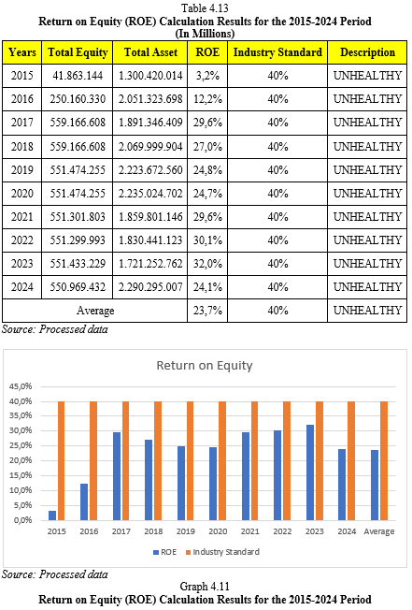
In 2016, PT Nasional Pelabuhan Handal Tbk's Return on Equity increased significantly by 9% to 12.2%. This was due to an increase in total equity and total assets.
Then in 2017, PT Nasional Pelabuhan Handal Tbk's Return on Equity increased again by 17.4% to 29.6%. This increase occurred due to an increase in total equity and total assets of the company, but this increase did not make the company's Return on Equity meet industry standards.
Then in 2020, PT Nasional Pelabuhan Handal Tbk's Return on Equity experienced a significant decline of 4.8% to 24.8%. This decline occurred due to a slight decrease in total assets, even though total equity remained the same as the previous year. This condition was also an impact of the COVID-19 pandemic, which hampered the economy.
In 2023, the company's Return on Equity increased again compared to the previous year by 7.2% to 32.0%. This was due to an increase in total equity.
In 2024, PT Nasional Pelabuhan Handal Tbk's Return on Equity decreased by 7.9% to 24.1%. This was due to a further decline in total equity. However, this still did not enable the company to meet industry standards.
Based on these results, the average Return on Equity of PT Nasional Pelabuhan Handal Tbk for the 2015-2024 period was 23.7%. This result is still not good enough to meet the company's industry standard of 40%.
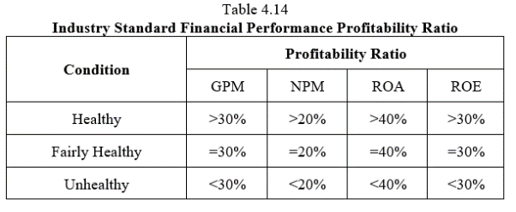

Discussion
Based on the results of the research conducted, the financial ratio analysis of PT Nasional Pelabuhan Handal Tbk for the period 2015–2024 provides a comprehensive overview of the company's liquidity, solvency, activity, and profitability. In general, the results of the study show that the liquidity and solvency ratios are in fairly good condition, while the activity and profitability ratios are still below industry standards.
These findings are in line with the research objective, which is to measure the company's financial performance through financial ratio analysis to determine the company's ability to meet short-term obligations, manage capital structure, utilize assets, and generate profits. Based on the results obtained, the company is considered capable of maintaining short-term financial stability, but still faces challenges in asset utilization efficiency and profitability improvement.
From a theoretical framework perspective, the results of this study support the theory of operational efficiency, whereby higher asset turnover indicates that a company is more efficient in generating revenue. However, with an average Total Asset Turnover (TATO) of 0.02 times, PT Nasional Pelabuhan Handal Tbk has not been able to achieve the expected level of efficiency. This reinforces the view of Brigham & Houston (2019) that capital-intensive industries, such as ports and logistics, tend to have low asset turnover because most assets are fixed and long-term.
Furthermore, the research results are also relevant to the Capital Structure Theory proposed by the Pecking Order Theory and Trade-Off Theory, where moderate use of debt can have a positive leverage effect on profits. This is reflected in the company's solvency ratios, which are within safe limits (DAR 50%, DER 120%), indicating the company's ability to maintain a balance between equity and debt without incurring excessive financial risk.
From the perspective of previous research, these results are in line with Tambunan's (2021) findings, which state that low activity ratios in Indonesian port companies have a direct impact on low profitability. In addition, the results of this study also reinforce Hidayat's (2022) findings that liquidity ratios have a negative relationship with profitability, because excess current assets can reduce investment effectiveness.
Scientifically, this study contributes by strengthening empirical evidence regarding the relationship between asset efficiency and profitability in the national port sector over the past decade. These results emphasize the importance of efficient asset management in improving the competitiveness of port companies in Indonesia.
From a practical perspective, these findings have implications for the management of PT Nasional Pelabuhan Handal Tbk to focus more on strategies to improve asset efficiency and optimize port terminal capacity. Management is advised to increase the productivity of fixed assets, maximize the use of digital port technology, and develop value-added services to expand revenue without increasing the asset burden.
However, this study has limitations because it only uses a quantitative descriptive approach based on secondary financial statement data without more in-depth inferential statistical analysis. Therefore, further research is expected to use regression or panel data analysis methods to test the causal relationship between liquidity, solvency, activity, and profitability on financial performance simultaneously and partially, so that the results can be more comprehensive.

Conclusion
From all the research results regarding the analysis of Liquidity, Solvency, Activity, and Profitability Ratios to measure the financial performance of PT Nasional Pelabuhan Handal Tbk for the period 2015-2024, it can be concluded that:
- Liquidity Ratio at PT Nasional Pelabuhan Handal for the period 2015-2024
Financial performance is measured by the liquidity ratio:
- The development of the Current Ratio at PT Nasional Pelabuhan Handal Tbk for the period 2015 to 2024 shows an UNHEALTHY condition. This is because the overall average of the Liquidity Ratio calculation is 163.6%, which does not meet the industry standard of 200%. It can be said to be UNHEALTHY because the company is unable to manage its current assets and pay its current liabilities properly, so the company must optimize its performance even better.
- The results of the Quick Ratio performance development at PT Nasional Pelabuhan Handal Tbk for the period 2015 to 2024 show an UNHEALTHY condition. This is because the average overall result of the company's Quick Ratio calculation of 123.3% does not meet the industry standard of 150%. It can be said that the company's performance is UNHEALTHY because it is unable to meet and pay its obligations or liabilities with its current assets.
- The results of the Cash Ratio performance development at PT Nasional Pelabuhan Handal Tbk for the period from 2015 to 2024 show a HEALTHY condition. This is because the Cash Ratio shows an average of 63.8%, which meets the industry standard of 50%. It can be said to be HEALTHY because the company has been able to manage cash and cash equivalents for short-term needs well, resulting in outcomes that are in line with the company's industry standards.
- Solvency Ratio at PT Nasional Pelabuhan Handal Tbk for the Period 2015-2024
Financial performance is measured by the solvency ratio:
  - The results of the Debt to Equity Ratio performance at PT Nasional Pelabuhan Handal Tbk for the period 2015 to 2024 show that it is UNHEALTHY. This is because the overall average result of the company's Debt to Equity Ratio is 464.6%, which is above the company's industry standard of 90%. This is because the higher the company's DER ratio, the less able the company is to meet all of its obligations. It can be concluded that the DER at PT Nasional Pelabuhan Handal Tbk is UNHEALTHY.
  - The results of the Debt to Asset Ratio performance of PT Nasional Pelabuhan Handal Tbk for the period 2015 to 2024 show that it is UNHEALTHY. This is indicated by the average Debt to Asset Ratio of the company, which is 57.3%, which is above the industry standard of 35%, because the higher the DER ratio, the less able the company is to meet all of its obligations.
- Activity Ratio at PT Nasional Pelabuhan Handal Tbk for the Period 2015-2024
Financial performance is measured by activity ratios:
  - The development of the Total Asset Turnover Ratio at PT Nasional Pelabuhan Handal for the period 2015 to 2024 shows an UNHEALTHY or POOR condition. This is because the company's overall average TATO of 0.02 times has not been able to meet the industry standard of 2 times. The company's Total Asset Turnover Ratio can be said to be UNHEALTHY because the company has not been able to maximize its sales.
  - The performance of the Fixed Asset Turnover Ratio at PT Nasional Pelabuhan Handal Tbk for the period 2015 to 2024 shows an UNHEALTHY condition. This is because the company's overall average FATO is 0.03 times, which does not meet the industry standard of 5 times. The company is considered UNHEALTHY because it has not been able to optimally manage its fixed assets to generate sales or revenue for the company.
- Profitability Ratio at PT Nasional Pelabuhan Handal Tbk for the Period 2015-2024
Financial performance is measured by the Profitability Ratio:
  - The development of Gross Profit Margin performance at PT Nasional Pelabuhan Handal Tbk for the period 2015 to 2024 shows an UNHEALTHY condition. This is because the average result of the company's overall GPM of 26.8% has not been able to meet the industry standard value of 30%. The company is considered UNHEALTHY due to a decline in gross profit and an increase in cost of goods sold that is not balanced with the decline in gross profit.
  - The development of Net Profit Margin performance at PT Nasional Pelabuhan Handal Tbk for the period 2015 to 2024 shows an UNHEALTHY condition. This is because the company's overall average NPM of -1.3% has not been able to meet the industry standard of 20%. The company can be said to be UNHEALTHY because it has not been able to manage its net profit after tax and there has been a decline that is not balanced with the company's revenue.
  - The development of Return on Assets at PT Nasional Pelabuhan Handal Tbk from 2015 to 2024 shows an UNHEALTHY condition. This is because the company's overall average ROA of -0.6% has not been able to meet the industry standard of 30%. The company can be considered UNHEALTHY because it has not been able to manage its net profit to achieve better results.
  - The results of Return on Equity performance at PT Nasional Pelabuhan Handal for the period 2015 to 2024 show an UNHEALTHY condition. This is because the average ROE of the company, which is 23.7%, has not been able to meet the industry standard value of 40%. The company can be considered UNHEALTHY due to the size of its total assets, but the total equity generated by the company is not good. In addition, the company has not been able to manage its capital efficiently, as seen from the ability of its equity to generate profits or income.

References
World Bank. (2021). Port Development and Logistics in Southeast Asia: Opportunities and Challenges. Washington D.C.: The World Bank Group.
PT Nasional Pelabuhan Handal Tbk. (2023). Laporan Tahunan 2023: Meningkatkan Konektivitas Maritim Indonesia. Jakarta: PT NPH Tbk.
Brigham, E. F., & Houston, J. F. (2019). Fundamentals of Financial Management (15th ed.). Cengage Learning.
Kasmir. (2022). Analisis Laporan Keuangan (Edisi Revisi). Jakarta: Rajagrafindo Persada.
Hidayat, R. (2022). Pengaruh Likuiditas, Solvabilitas, dan Aktivitas terhadap Profitabilitas pada Perusahaan Jasa Logistik yang Terdaftar di BEI. Jurnal Akuntansi dan Bisnis Indonesia, 10(2), 134–147.
Tambunan, R. (2021). Pengaruh Struktur Modal, Likuiditas, dan Aktivitas terhadap Profitabilitas pada Perusahaan Pelabuhan di Indonesia. Jurnal Riset Akuntansi dan Manajemen Pelabuhan, 5(1), 11–22.
Sugiyono. (2017). Metode Penelitian Kuantitatif, Kualitatif, dan R&D. Bandung: Alfabeta.
Sugiarto. (2016). Metodologi Penelitian Bisnis. Jakarta: PT Gramedia Pustaka Utama.
Arikunto, S. (2017). Prosedur Penelitian: Suatu Pendekatan Praktik. Jakarta: Rineka Cipta.
Juliandi, A., Irfan, & Manurung, S. (2015). Metodologi Penelitian Bisnis: Konsep dan Aplikasi. Medan: UMSU Press.
Munawir, S. (2002). Analisis Laporan Keuangan. Yogyakarta: Liberty.
Kasmir. (2016). Analisis Laporan Keuangan. Jakarta: Rajawali Pers

