ANALYSIS OF THE RELATIONSHIP BETWEEN LIQUIDITY AND SOLVENCY RATIOS AS FINANCIAL PERFORMANCE INDICATORS AT PT ENSEVAL PUTERA MEGATRADING TBK 2015–2024

Wanda Kenanga

Pamulang University, South Tangerang
wandakenangaa33@gmail.com

Abstract
This research investigates the correlation between liquidity and solvency ratios as measures of financial performance at PT Enseval Putera Megatrading Tbk over the 2015–2024 period. Liquidity indicates the firm’s capability to fulfill its short-term liabilities, whereas solvency demonstrates its ability to handle long-term financial commitments and maintain a stable capital structure. The study adopts a quantitative methodology utilizing secondary financial data and statistical analysis conducted through SPSS, encompassing descriptive statistics, the Kolmogorov–Smirnov normality test, and Pearson correlation analysis. The results show that liquidity and solvency have a strong negative correlation, indicating that higher liquidity levels tend to reduce the company’s dependence on debt financing. Overall, the findings suggest that PT Enseval Putera Megatrading Tbk has maintained a healthy financial position and an efficient balance between liquidity and solvency during the study period. This study offers valuable insight into the significance of effectively managing liquidity and leverage to maintain sustainable long-term financial stability.

Keywords:
Liquidity, Solvency, Current Ratio, Quick Ratio, Debt to Equity Ratio, Debt Ratio, Colleration, Financial Performance, PT Enseval Putera Megatrading Tbk

Introduction
Financial performance is a fundamental aspect that reflects a company's ability to manage its financial resources efficiently and effectively to achieve operational and strategic objectives. According to Kieso, Weygandt, and Warfield (2020), financial statements serve as the main tool utilized for evaluating an organization's financial performance through various ratios that reflect its liquidity, solvency, profitability, and activity.
Financial ratios are used as analytical tools that help management, investors, and other external parties assess a company's financial condition. Brigham and Houston (2019) state that ratio analysis is an effective method for evaluating a company's financial strengths and weaknesses and monitoring changes in performance over time.

Liquidity ratios describe a company's ability to meet its short-term obligations without having to sell fixed assets or obtain additional funding, while solvency ratios show the extent to which a company is able to meet all of its long-term obligations. The balance between these two ratios is an important indicator in assessing the financial health of an entity (Van Horne & Wachowicz, 2018).
PT Enseval Putera Megatrading Tbk is among the leading pharmaceutical distribution companies in Indonesia, operating as a subsidiary of PT Kalbe Farma Tbk. In carrying out its business operations, the company encounters challenges in maintaining liquidity and solvency amid market fluctuations and national economic conditions. Hence, this research seeks to examine the relationship between liquidity and solvency ratios as indicators of the company’s financial performance over the 2015–2024 period.
This study is expected to contribute empirically to the corporate finance literature and serve as a consideration for management and investors in assessing the company's financial performance and capital structure stability.

Theoretical Framework
1. Liquidity Ratios
The liquidity ratio is a ratio used to measure a company's ability to meet its short-term obligations using its current assets (Gitman & Zutter, 2015). This ratio reflects the level of financial security of a company in facing liquidity risk.
Commonly used indicators include:
Current Ratio (CR) = Current Assets / Current Liabilities
Quick Ratio (QR) = (Current Assets − Inventory) / Current Liabilities
A high liquidity ratio reflects a firm’s strong capacity to fulfill its short-term liabilities; however, an excessively high ratio may suggest that current assets are not being utilized efficiently.
2. Solvency Ratios
Solvency ratios serve to evaluate a company’s capability to meet its long-term financial commitments. According to Horne and Wachowicz (2018), these ratios reflect the extent to which a company is financed by debt compared to its equity.
Commonly used indicators include:
Debt Ratio (DR) = Total Debt / Total Assets
Debt to Equity Ratio (DER) = Total Debt / Total Equity
The higher the solvency ratio, the larger the share of the company’s financing derived from debt, which consequently elevates its financial risk. However, an optimal level of solvency can improve capital efficiency and strengthen the company's financial structure.
3. The Relationship between Liquidity and Solvency and Financial Performance
According to Weston and Copeland (2014), liquidity and solvency are two important aspects that are interrelated in determining a company's financial stability. Good liquidity reflects a company's ability to maintain short-term operations, while stable solvency indicates long-term financial strength. A balanced relationship between the two reflects a sound capital structure, which ultimately contributes to enhancing the company’s financial performance.
Previous research conducted by Putra and Dewi (2021) shows that there is a positive relationship between liquidity and solvency ratios in maintaining a company's financial performance, although excessive increases in liquidity can reduce working capital efficiency.
4. Variable Relationship Framework
Thus, this research framework states that liquidity ratios and solvency ratios are independent variables that impact (or are related to) a company's financial performance as a dependent variable (although in your research you focus more on the correlation than the full causal effect). The general figure is:
The relationship between liquidity and solvency can also be mutually influential: for example, high liquidity can be associated with healthier solvency.
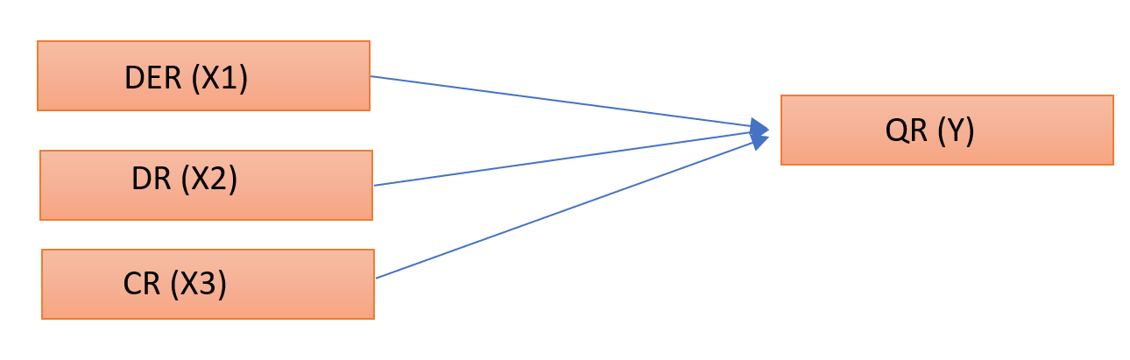
Method
This study uses a quantitative approach with descriptive and inferential analysis methods. The purpose of this study is to determine the relationship between liquidity ratio and solvency ratio in measuring the financial performance of PT Enseval Putera Megatrading Tbk during the period 2015–2024. A quantitative approach was chosen because this study focuses on analyzing numerical data to identify relationships between variables objectively through statistical testing.
The data utilized in this research consists of secondary information derived from the annual financial statements of PT Enseval Putera Megatrading Tbk, which are publicly available on the official websites of the Indonesia Stock Exchange (www.idx.co.id) and the company itself (www.enseval.com). The dataset encompasses a ten-year period, from 2015 to 2024. The study employs two categories of financial ratios: liquidity ratios—measured using the Quick Ratio (QR) and Current Ratio (CR)—and solvency ratios—measured using the Debt Ratio (DR) and Debt to Equity Ratio (DER). The ten-year timeframe was chosen to provide a comprehensive assessment of the company’s financial performance stability over time.
The analytical procedure comprises three primary stages: descriptive analysis, the Kolmogorov–Smirnov normality test, and the Pearson correlation test. Descriptive analysis is employed to explain the characteristics of each research variable, including the minimum, maximum, mean, and standard deviation values, in order to present an overview of the company’s liquidity and solvency conditions throughout the study period. According to Sugiyono (2019), descriptive analysis is a method used to describe or illustrate data as it is without intending to make general conclusions.

Subsequently, the Kolmogorov–Smirnov normality test is applied to assess whether the dataset follows a normal distribution—an essential prerequisite for conducting parametric correlation analysis. This test is performed at a 0.05 significance level, where data are considered normally distributed if the significance value (Sig.) exceeds 0.05. According to Ghozali (2018) in his book Application of Multivariate Analysis with IBM SPSS Program, the Kolmogorov-Smirnov test is used to test data normality by comparing the distribution of sample data against the theoretical normal distribution.
Once the normality assumption is satisfied, the Pearson correlation test is utilized to identify both the direction and the strength of the relationship between liquidity and solvency ratios. This test is appropriate because the variables are measured on a ratio scale and meet the normality criteria. The correlation coefficient (r) ranges from –1 to +1, with positive values indicating a direct relationship and negative values indicating an inverse one. The criteria for correlation strength are interpreted according to Sugiyono (2019), namely: 0.00–0.199 (very weak), 0.20–0.399 (weak), 0.40–0.599 (moderate), 0.60–0.799 (strong), and 0.80–1.00 (very strong).
The results of this correlation analysis are used to identify the extent to which the relationship between liquidity ratios and solvency ratios reflects a company's financial performance. Thus, this research method provides a strong foundation for explaining the relationship between a firm’s capacity to fulfill short-term liabilities and its effectiveness in managing its overall capital structure.

Results
Analysis of Liquidity at EMPT for the Period 2015-2024
Table 1. the Author’s Data Based on EPMT’s Financial Statements.
Year | CR (%) | QR (%)
2015 | 217 | 139
2016 | 252 | 162
2017 | 280 | 173
2018 | 285 | 190
2019 | 289 | 192
2020 | 298 | 206
2021 | 294 | 179
2022 | 278 | 164
2023 | 260 | 152
2024 | 254 | 150

Based on the data presented in the table above, the company’s Current Ratio (CR) and Quick Ratio (QR) from 2015 to 2024 exhibit a relatively fluctuating pattern, although overall liquidity remains stable. The Current Ratio rose from 217% in 2015 to its highest point of 298% in 2020, reflecting a notable improvement in the company’s capability to fulfill short-term obligations. Nevertheless, after 2020, the CR began to decline, reaching 254% in 2024, which may be attributed to a reduction in current assets or an increase in current liabilities. A similar trend is observed in the Quick Ratio, which climbed from 139% in 2015 to 206% in 2020 before decreasing again to 150% in 2024. Despite this decline, the QR consistently remaining above 100% suggests that the company maintains a strong ability to settle short-term debts without depending on inventory liquidation. Overall, both CR and QR show a similar movement, indicating stable company liquidity despite a slight decline at the end of the observation period.

Analysis of Solvability at EPMT for the Period 2015-2024
Table 2. the Author’s Data Based on EMPT’s Financial Statements.
Year | DER (%) | DR (%)
2015 | 650 | 40
2016 | 599 | 35
2017 | 557 | 31
2018 | 615 | 34
2019 | 625 | 31
2020 | 644 | 30
2021 | 700 | 31
2022 | 793 | 34
2023 | 889 | 35
2024 | 950 | 36

Based on the data in the table above, it can be seen that PT Enseval Putera Megatrading Tbk's Debt to Equity Ratio (DER) fluctuated significantly during the period from 2015 to 2024. In 2015, the DER was recorded at 650%, which means that the company's total debt was 6.5 times its total equity. This value indicates that the company used external funding in a high proportion compared to its own capital. However, from 2016 to 2017, the DER decreased to 599% and 557%, respectively, indicating the company's efforts to reduce its dependence on debt financing.
From 2018 to 2020, the DER again showed a moderate upward trend, ranging from 615% to 644%, indicating that the company's capital structure began to be dominated by debt again. This increase may reflect the need for additional funding for the company's expansion or operational improvements. A more significant increase occurred in the period from 2021 to 2024, where the DER increased continuously from 700% to 950% by the conclusion of the observation period. This indicates an increase in the use on debt as the primary source of funding, which has the potential to increase the company's financial risk if it is not balanced with an increase in profitability and adequate operating cash flow.
Meanwhile, the Debt Ratio (DR) shows the proportion of total debt to total assets owned by the company. In general, PT Enseval Putera Megatrading Tbk's DR value has been relatively stable over the last ten years, ranging from 30% to 40%. In 2015, the Debt Ratio (DR) stood at 40%, indicating that 40% of the company’s total assets were funded through debt. This ratio then decreased to 30% in 2020, indicating an improvement in the funding structure through an increase in equity or a reduction in liabilities.
However, from 2021 to 2024, the DR will increase slightly to a range of 31%–36%, indicating additional liabilities in the company's financial structure. Nevertheless, this value is still at a relatively safe level because the proportion of debt to assets does not exceed 50%. According to Kasmir (2018) in the book Financial Statement Analysis, the ideal Debt Ratio value is below 50%, as this indicates that the company still has a good ability to meet its long-term liabilities without causing excessive financial pressure.
Overall, the analysis results show that during the 2015–2024 period, PT Enseval Putera Megatrading Tbk was still able to maintain its solvency at a relatively stable level despite an increase in the DER ratio in recent years. This indicates that the company still has good capacity to manage debt to support its operational activities and business growth, as long as it continues to pay attention to the balance between equity and loan capital in its capital structure.

Descriptive Statistics Analysis
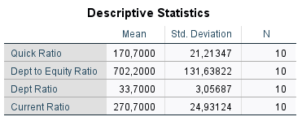
Figure 1. Result of Data Analysis Descriptive Statistics using SPSS.
The table above shows the results of descriptive analysis of four financial ratios, namely Quick Ratio, Debt to Equity Ratio, Debt Ratio, and Current Ratio with a total of 10 years of observations (N = 10).
1. Quick Ratio (Mean = 170.70; Std. Deviation = 21.21)
The average Quick Ratio of 170.70% shows that the company possesses an excellent capacity to fulfill its short-term obligations without having to sell inventory. The standard deviation value of 21.21 indicates relatively small variation, suggesting that the company’s liquidity level is quite stable from year to year.
2. Debt to Equity Ratio (Mean = 702.20; Std. Deviation = 131.64)
The mean Debt to Equity Ratio of 702.20% indicates that the company’s capital structure is primarily debt-driven rather than equity-based. This reflects a high degree of financial leverage. The standard deviation of 131.64 is quite large, indicating fluctuations in the proportion of debt to capital between periods.
3. Debt Ratio (Mean = 33.70; Std. Deviation = 3.06)
The average Debt Ratio of 33.70% indicates that approximately one-third of the company’s total assets are supported by debt. The small standard deviation of 3.06 indicates a fairly stable financing structure during the observation period.
4. Current Ratio (Mean = 270.70; Std. Deviation = 24.93)
The average Current Ratio of 270.70% indicates that the company’s current assets amount to three times its current liabilities, meaning that the company is highly liquid. The standard deviation of 24.93 indicates moderate variation, meaning that the company's liquidity is relatively stable but experiences slight changes from year to year.
Data Normality Test (Kolmogorov–Smirnov)
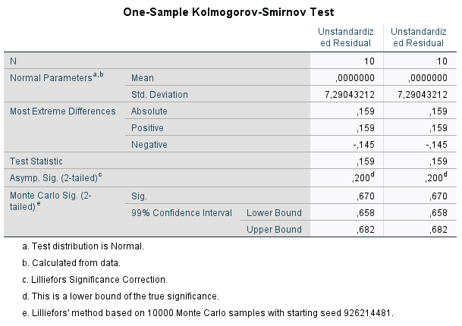
Figure 2. Result of Data Analysis One-Sample Kolmogorov using SPSS.

The Asymp. Sig. (2-tailed) value is 0.200, exceeding the 0.05 significance threshold (0.200 > 0.05). This suggests that the residuals follow a normal distribution, allowing the conclusion that: “The research data consisting of the liquidity and solvency ratios of PT Enseval Putera Megatrading Tbk for the 2015-2024 period is normally distributed.”
Correlation Analysis Between Liquidity and Solvency Ratios
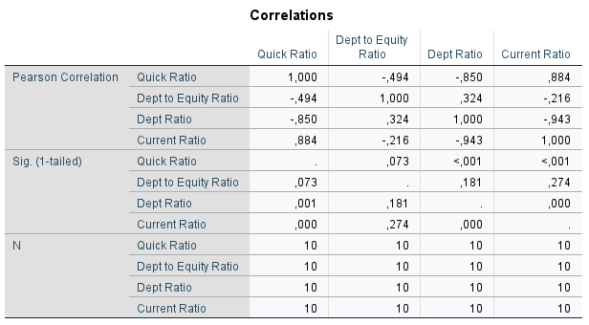
Figure 3. Result of Data Analysis Correlations using SPSS.
The table above shows the relationship between financial variables: Quick Ratio, Debt to Equity Ratio, Debt Ratio, and Current Ratio — complete with significance values (Sig. 1-tailed) and sample size (N = 10).
1. Relationship between Quick Ratio and Debt to Equity Ratio
The analysis shows a correlation coefficient of -0.494 with a significance level of 0.073. This outcome suggests that while there is a moderate negative association between the Quick Ratio and Debt to Equity Ratio, the relationship is not statistically significant, as the significance value exceeds 0.05. In practical terms, this implies that an increase in a company's liquidity, as measured by the Quick Ratio, does not have a statistically verified relationship with its capital structure represented by the debt to equity ratio.
2. Relationship between Quick Ratio and Debt Ratio
The correlation coefficient between the Quick Ratio and Debt Ratio is -0.850, with a significance value of 0.001. This result demonstrates a strong and statistically significant negative correlation between the two variables. Therefore, companies with higher Quick Ratios tend to have lower Debt Ratios, indicating that firms with greater liquidity levels generally possess less debt within their capital structure.
3. Relationship between Quick Ratio and Current Ratio
The correlation analysis yields a coefficient of 0.884 with a significance value of 0.000. This finding highlights a very strong and statistically significant positive correlation between the Quick Ratio and Current Ratio. It indicates that as the Current Ratio increases, the Quick Ratio is also likely to rise. Consistent with financial theory, both ratios represent a firm's capacity to fulfill its short-term liabilities, so their movements are usually in the same direction.
4. Relationship between Debt to Equity Ratio and Debt Ratio
The correlation value between Debt to Equity Ratio and Debt Ratio is 0.324 with a significance value of 0.181. This result shows a weak and insignificant positive relationship between the two variables. This means that although in theory an increase in total debt can have an impact on an increase in Debt to Equity Ratio, in this research data the relationship is not statistically proven.
5. Relationship between Debt Ratio and Current Ratio
The correlation analysis presents a coefficient of -0.943, with a significance value of 0.000. This relationship is very strong and significant. This means that the higher the Debt Ratio of a company, the lower its Current Ratio. This condition reflects that companies with high debt levels tend to have lower liquidity, because most of their assets are used to cover liabilities.

Discussion
Drawing upon the descriptive analysis of PT Enseval Putera Megatrading Tbk’s financial statements for 2015–2024, it may be inferred that the company's liquidity exhibited a consistent pattern, marked by an upward movement through 2020, followed by a moderate decrease up to 2024. The company's Current Ratio (CR) moved from 217% in 2015 to 298% in 2020, before declining to 254% in 2024. Meanwhile, the Quick Ratio (QR) experienced similar fluctuations, increasing from 139% in 2015 to 206% in 2020, then decreasing to 150% in 2024. On average, the CR was 270.9% and the QR was 170.5%, indicating demonstrating the company’s strong capacity in fulfilling its short-term liabilities. According to Kasmir (2018), a liquidity ratio above 200% reflects a healthy financial condition because current assets are able to cover current liabilities more than twice over. Thus, it can be said that PT Enseval Putera Megatrading Tbk was in a strong liquidity position throughout the research period.
In terms of solvency, the data shows that the firm's Debt to Equity Ratio (DER) and Debt Ratio (DR) have been relatively stable with an upward trend in the last five years. The DER value increased from 650% in 2015 to 950% in 2024, indicating that the portion of debt to equity is getting bigger. On the other hand, the Debt Ratio (DR) tends to be stable in the range of 30%–40%, with an average value of 33.7%. This value indicates that approximately one-third of the corporation’s assets are supported through debt financing, which is still within reasonable limits according to the standards of the pharmaceutical distribution and wholesale trade industry. According to Brigham and Houston (2019), a high DER indicates aggressive leverage, but when accompanied by good risk control, it can increase the potential return for shareholders. Thus, the company is able to maintain a balance between the use of its own capital and external funds.
The Kolmogorov-Smirnov The results of the normality assessment indicate a significance level of 0.200, which exceeds 0.05, thus confirming that the financial data conforms to a normal distribution. This means that all research variables meet the basic assumptions for parametric analysis. In accordance with Ghozali (2018), normally distributed data can be used in Pearson's correlation test to assess the relationship between variables validly.
The results of the Pearson correlation testing demonstrates a notable link between liquidity and solvency. The correlation between the Current Ratio and Quick Ratio shows a robust positive correlation coefficient of 0.884 accompanied by a significance value of 0.000, indicating that an increase in a company's ability to maintain current assets is directly proportional to an increase in overall liquidity. Conversely, the interconnection involving the Quick Ratio and Dept to Ratio shows a strong negative correlation of -0.850 with a significance of 0.001, which means that the higher the company's liquidity, the lower the proportion of assets financed by debt. A similar negative relationship was also found between the Current Ratio and the Debt Ratio with a correlation value of -0.943 (sig. 0.000). This reinforces the finding Organizations demonstrating substantial liquidity typically exhibit greater financially independent and less dependent on external financing.
However, the relationship between the Quick Ratio and the Debt to Equity Ratio (DER) shows a correlation of -0.494 accompanied by a significance level of 0.073, which means a negative but statistically insignificant relationship. This means that an increase in liquidity is not always followed by a decrease in DER, because companies still use debt in certain proportions for business expansion. This condition is in line with the capital structure theory proposed by Modigliani and Miller (1963), which states that moderate use of debt can increase company value as long as it remains at a controllable level of risk.
Overall, the data trends show that PT Enseval Putera Megatrading Tbk was able to maintain a solid financial position during the research period. High liquidity strengthens the organization’s capacity to fulfill its short-term liabilities, while a stable solvency ratio indicates efficient capital structure management. The negative correlation between these two aspects confirms that increased liquidity contributes to a reduction in dependence on debt financing, thereby strengthening long-term financial stability.

Conclusion
Based on the evaluation of financial data for PT Enseval Putera Megatrading Tbk from 2015 to 2024, it can be inferred that the company’s overall financial status remains both sound and stable. The liquidity ratios, specifically the Current Ratio (CR) and Quick Ratio (QR), demonstrate the firm's strong capability to fulfill its short-term financial commitments. With an average CR of 270.9% and QR of 170.5%, the company holds adequate current assets to cover its current liabilities more than twice. Despite a slight decline in recent years, the liquidity level remains in the safe category according to financial analysis standards.
In terms of solvency, the Debt to Equity Ratio (DER) and Debt Ratio (DR) calculations show that the company is still able to maintain a balance between the use of its own capital and external funds. The high average DER of 702.24% indicates a fairly high level of leverage, but the relatively stable DR value in the range of 30%–40% indicates that the proportion of assets financed by debt is still within reasonable limits. This condition illustrates that PT Enseval Putera Megatrading Tbk is able to manage its capital structure effectively without causing excessive financial risk.
The results of the Kolmogorov-Smirnov normality test with a significance value of 0.200 confirm that the data is normally distributed, so that the Pearson correlation test can be carried out with good validity. Based on the correlation test results, a strong negative relationship was found between liquidity ratios (CR and QR) and solvency ratios (DER and DR). This indicates that the higher the company's liquidity level, the lower its dependence on debt financing. Conversely, the significant positive correlation between CR and QR shows consistency regarding how the company oversees its current asset portfolio.
Thus, it may be inferred that PT Enseval Putera Megatrading Tbk has solid financial performance and effective financial management during the research period. High liquidity contributes to long-term financial stability and reduces pressure on debt use. However, the company still needs to pay attention to increasing leverage (DER) to ensure potential financial difficulties are avoided going forward. Overall, the results of this study support the theories proposed by Kasmir (2018), Brigham and Houston (2019), and Modigliani and Miller (1963), that the balance between liquidity and solvency is a major factor in maintaining the sustainability and stability of a company's financial performance.

Acknowledgments
The author extends sincere appreciation to Pamulang University, specifically the Faculty of Economics and Business, for providing invaluable academic support and institutional resources throughout this research. Grateful acknowledgment is directed to the faculty members and advisors who have shared their expertise and thoughtful guidance. The author also wishes to thank PT Enseval Putera Megatrading Tbk for granting access to financial data essential for this study. Recognition is also due to colleagues and fellow students for their collaborative spirit and assistance with data analysis and interpretation. Lastly, heartfelt thanks are offered to family and friends whose encouragement and patience were instrumental during the completion of this work.

References
Brigham, E. F., & Houston, J. F. (2019). Fundamentals of Financial Management (15th ed.). Cengage Learning.
Gitman, L. J., & Zutter, C. J. (2015). Principles of Managerial Finance (14th ed.). Pearson Education.
Putra, I. P., & Dewi, N. K. S. (2021). “Pengaruh Likuiditas dan Solvabilitas terhadap Kinerja Keuangan Perusahaan Manufaktur di BEI.” Jurnal Ilmu dan Riset Akuntansi, 10(3), 1–12.
Van Horne, J. C., & Wachowicz, J. M. (2018). Fundamentals of Financial Management (15th ed.). Pearson Education.
Kasmir. (2018). Analisis Laporan Keuangan. Jakarta: Rajawali Pers.

