Analysis Of The Effect Of Capital Structure (Solvency) On Profitability At PT Telkom Indonesia (Persero) Tbk 2015-2024

Rintan Nirmala

Pamulang University, South Tangerang
rintannrmlaaa@gmail.com

Abstract
This study analyzes the effect of capital structure (solvency) on the profitability of PT Telkom Indonesia Tbk for the period 2015–2024. Capital structure is assessed using the Debt to Asset Ratio (DAR) and Debt to Equity Ratio (DER), while profitability is evaluated through Return on Assets (ROA) and Net Profit Margin (NPM). A quantitative descriptive approach was employed, utilizing secondary data sourced from the company’s financial statements. The results show that DAR and DER were in the range of 41%–51% and 70%–104%, reflecting a healthy and stable capital structure despite an increase in debt in 2020 to support operations during the pandemic. Profitability, although declining after 2017, remained at a healthy level, with ROA and NPM as the main indicators. The F statistical test confirmed the significant simultaneous effect of capital structure and NPM on ROA. However, the partial t-test revealed that only NPM had a significant effect on ROA, while DAR and DER were insignificant. Thus, PT Telkom's profitability is determined more by the efficiency of net profit management than by debt utilization policies. This study implies that focusing on effective net profit management is more crucial than the level of leverage in maintaining and improving the company's profitability amid the dynamics of the economy and the telecommunications industry.

Keywords:
Capital Structure, Solvency, Profitability, Debt to Asset Ratio (DAR), Debt to Equity Ratio (DER), Return on Assets (ROA), Net Profit Margin (NPM).

Introduction
Companies are required to maintain financial stability in the face of increasingly fierce business competition. Financial ratio analysis, especially focusing on profitability and solvency ratios, serves as a key method for evaluating a company’s financial performance. Profitability is a ratio that measures the overall effectiveness of management in terms of the level of profit obtained in relation to sales and investment (Fahmi, 2014). Meanwhile, the solvency ratio describes the extent to which a company's assets are financed by debt. A solvable company means that the company has sufficient assets or wealth to pay all its debts, but this does not necessarily mean that the company is liquid (Barus et al., 2017).
Capital structure is one of the most important components that must be managed and used effectively and efficiently to increase company profitability (Rosyadah, 2013). Capital structure is an important aspect in financial decision making because it is directly related to the level of risk and the company's ability to make a profit. Companies with a high proportion of debt are at risk of financial pressure due to increased interest expenses, which can ultimately reduce profitability.
PT Telkom Indonesia Tbk is one of the largest telecommunications companies in Indonesia with a complex financial structure and extensive operational activities. As a public company, Telkom is required to maintain a balance between capital structure and profitability in order to provide added value to shareholders. Fluctuations in net profit and changes in the debt-equity composition over the past few years are interesting phenomena to analyze, especially in the context of capital efficiency and profit-generating capabilities.
This research seeks to examine the impact of capital structure, indicated by DAR and DER, on profitability, represented by ROA and NPM, at PT Telkom Indonesia Tbk for the period 2015-2024. Through this research, it is hoped that a deeper understanding of the relationship between solvency and profitability can be gained, as well as provide consideration for company management in determining optimal funding policies.

Theoretical Framework
Solvency Ratio (Capital Structure)
The solvency ratio or capital structure describes the extent to which a company is financed by debt compared to its own capital. According to Riyanto (2018:297), capital structure is “the balance between the amount of long-term debt and the company's own capital.” This ratio shows the company's ability to meet its long-term obligations and reflects the company's level of financial risk. This study uses two main solvency indicators:
1. Debt to Assets Ratio (DAR)
DAR = (Total Debt / Total Assets) x 100%
DAR measures how much of a company's total assets are financed by debt. The higher the DAR, the greater the dependence on external funds.
2. Debt to Equity Ratio (DER)
DER = (Total Debt / Total Equity) x 100%
DER describes the ratio between funds originating from creditors and shareholders. The higher the DER, the greater the financial risk because the company bears a higher interest burden.
Profitability Ratio
The profitability ratio is a metric used to assess a company’s capacity to generate earnings from its operational activities over a specific period. According to Kasmir (2019:196), “Profitability ratios aim to determine a company's ability to generate profits during a certain period and provide an overview of the effectiveness of the company's management.” Profitability ratios show how efficiently a company utilizes its assets, equity, or sales to generate profits.
In this research, two profitability indicators were used, namely:
1. Return on Assets (ROA)
ROA = (Net Profit / Total Assets) x 100%
ROA indicates a company’s capability to generate profits from its total assets. A higher ROA reflects greater efficiency in utilizing assets to produce earnings.
2. Net Profit Margin (NPM)
NPM = (Net Profit / Revenue) x 100%
NPM shows the percentage of net profit generated from every rupiah of sales. The higher the NPM, the greater the profit obtained from each sale.
3. Analysis of the Effect of Capital Structure (Solvency) on Profitability
Capital structure, as measured by solvency ratios (DER and DAR), shows the extent to which a company finances its assets with debt. Appropriate use of debt can increase profitability because interest on debt provides tax shields and allows companies to expand their operations. This is in line with the Trade-Off Theory, which explains that optimal use of debt can increase a company's profits.
However, if the proportion of debt is too high, interest expenses and financial risk increase, causing net profit to decline. This condition can put pressure on the company's Return on Assets (ROA) and Net Profit Margin (NPM). Based on the Pecking Order Theory, more profitable companies tend to avoid excessive use of debt and prefer internal financing to maintain financial stability.
Therefore, the effect of capital structure on profitability is two-way (positive or negative) depending on the level of leverage used. If PT Telkom Indonesia is able to manage its debt efficiently, healthy solvency will increase profitability. Conversely, if debt is excessive, the company's profitability will decline due to high interest expenses.
4. Inter-Variable Relationships (Variable Relationship Framework)
The Relationship Between Solvency and Profitability
- Positive effect: If debt usage can increase capital efficiency (because debt interest can reduce tax burdens), then profitability increases.
- Negative effect: If the proportion of debt is too high, interest costs and financial risks increase, causing profitability to decline.
According to Enow's (2023) research in the International Journal of Research in Business and Social Science, capital structure has a significant effect on profitability when managed in a balanced manner between debt and equity.
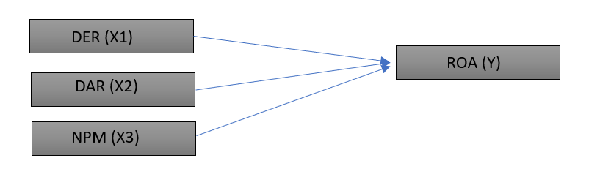
Information:
X1 : Debt to Equity Ratio
X2 : Debt to Asset Ratio
X3 : Net Profit Margin
Y : Return on Assets

Method
This research employs a descriptive quantitative approach with a causal-associative research design, aiming to examine the effect of capital structure (solvency) on profitability at PT Telkom Indonesia Tbk for the period 2015-2024. This approach is used because it is able to explain the cause-and-effect relationship between solvency and profitability variables objectively based on the company's financial data. The data used in this study is secondary data obtained from PT Telkom Indonesia Tbk's annual financial reports published on the company's official website (www.telkom.co.id) and the Indonesia Stock Exchange (www.idx.co.id). The population in this study is all of PT Telkom Indonesia Tbk's annual financial reports for the 2015–2024 period, while the sampling technique used is total sampling, where all available data during the research period is used as a sample.
This research examines two types of variables: independent and dependent. The independent variable (X) represents capital structure (solvency) and is quantified through two metrics: DAR and DER. Meanwhile, the dependent variable (Y) reflects profitability, evaluated by ROA and NPM. Data collection employed the documentation method, sourcing information from annual reports and official company publications to compute the relevant financial ratios.
Data analysis was conducted through several stages of testing. First, a normality test was performed to ensure that the data was normally distributed so that it met the requirements for linear regression analysis. Second, a multicollinearity test was conducted to identify any corellations among the independent variables that might affect the validity of the regression analysis. Third, an autocorrelation test was performed to detect whether there was a relationship between the residuals in the regression model. Subsequently, an F test (simultaneous) was performed to determine wether the capital structure variables (DAR and DER) collectively had a significant impact on profitability (ROA and NPM). Additionally, a Ttest (partial) was conducted to assess the effect of each independent variable on the dependent variable individually. The outcomes of these test were than used to draw conclusions regarding the influence of capital structure on profitability at PT Telkom Indonesia Tbk during the research period.
Results
Analysis of Solvency Ratio at TLKM for the period 2015-2024
Table 1. The Author’s Data Based on TLKM’s Financial Statements.
Year | DAR  (%) | DER (%)
2015 | 44 | 78
2016 | 41 | 70
2017 | 44 | 77
2018 | 43 | 76
2019 | 47 | 89
2020 | 51 | 104
2021 | 48 | 91
2022 | 46 | 84
2023 | 45 | 83
2024 | 46 | 84
Based on the results of the solvency ratio calculations for PT Telkom Indonesia Tbk for the period 2015–2024, the Debt to Assets Ratio (DAR) is in the range of 41%–51%, while the Debt to Equity Ratio (DER) ranges from 70%–104%. These results indicate that approximately half of the company's total assets are financed by debt, but this is still within safe and controlled limits. The increase in DAR and DER in 2020 indicates an increase in debt financing, most likely to support operations and investments amid economic pressures due to the pandemic. However, after that year, both ratios began to decline again, indicating an improvement in capital structure and debt management efficiency.
Overall, PT Telkom Indonesia Tbk's solvency level during the research period was healthy and stable, as the company was able to maintain a balance between the use of external funds and its own capital. This condition reflects the company's ability to meet its long-term obligations and manage its capital structure effectively to support its profitability.
Analysis of Profitability Ratio at TLKM for the period 2015-2024
Table 2. The Author’s Data Based on TLKM’s Financial Statements.
Year | ROA  (%) | NPM (%)
2015 | 14 | 23
2016 | 16 | 25
2017 | 16 | 25
2018 | 13 | 21
2019 | 12 | 20
2020 | 12 | 22
2021 | 12 | 24
2022 | 10 | 19
2023 | 11 | 22
2024 | 10 | 20
Based on the calculation of PT Telkom Indonesia Tbk's profitability ratio for the 2015–2024 period, the Return on Assets (ROA) value is in the range of 10%–16%, while the Net Profit Margin (NPM) ranges from 19%–25%. These results indicate that the company is still capable of generating good profits, despite a gradual decline after 2017. Profitability peaked in 2016–2017, when ROA and NPM reached 16% and 25%, respectively, reflecting high effectiveness in asset utilization and cost management efficiency. However, from 2018 to 2024, both ratios tended to decline—ROA fell to 10% and NPM to 20%—indicating a decline in efficiency and pressure on the company's profit performance.
Overall, despite the decline, Telkom's ROA and NPM values remain at relatively stable and healthy levels, indicating that the company is still able to maintain profitability amid industry dynamics and economic challenges during the research period.
Multicolinearity Test (Tolerance and VIF)
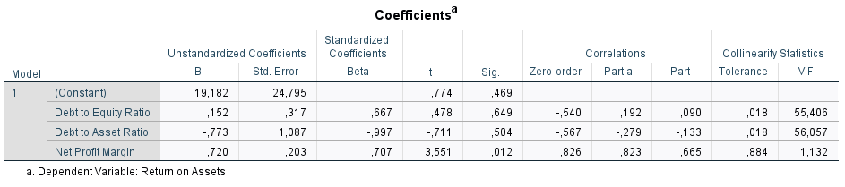
Figure 1. Result of Multicolinearity using SPSS
Based on the results of the multicollinearity test in the Coefficients table, it can be seen that the Debt to Equity Ratio (DER) and Debt to Asset Ratio (DAR) variables have Tolerance values of 0.018 and VIF values of 55.406 and 56.057, respectively. A Tolerance value that is much smaller than 0.10 and a VIF value that far exceeds 10 indicate that these two variables experience very high multicollinearity. Meanwhile, the Net Profit Margin (NPM) variable shows a Tolerance value of 0.884 and a VIF value of 1.132, which are still within normal limits (Tolerance > 0.10 and VIF < 10). Thus, it can be concluded that there is no multicollinearity in the NPM variable. Overall, these results indicate that the regression model used contains multicollinearity in the solvency variables (DER and DAR).

Normality Test
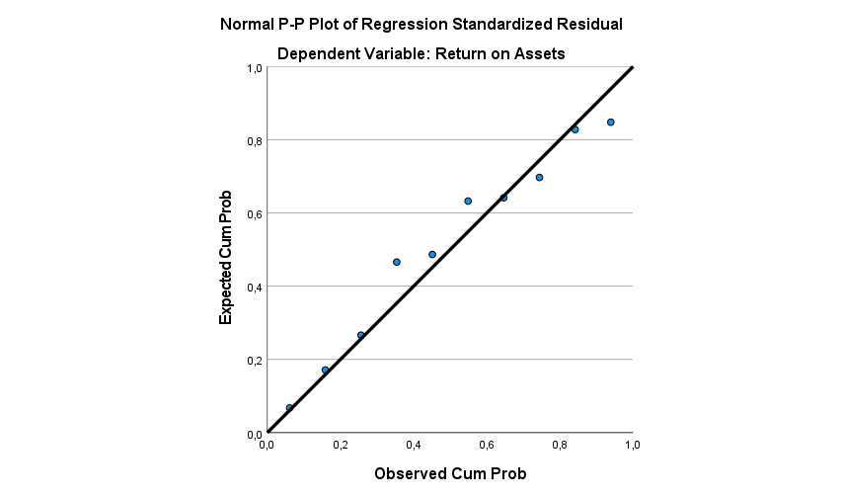
Figure 2. Result of Normality using SPSS

The figure presents the results of the normality test using the Normal P-P Plot of Regression Standardized Residuals for the dependent variable, Return on Assets (ROA). Based on the graph, the points (residual data) are distributed around the diagonal line and follow its direction relatively closely. The distribution of residuals appears to be nearly normal, indicating that the assumption of normality is satisfied.
Autocorrelation Test (Durbin-Watson)
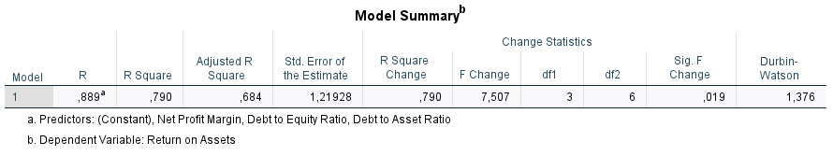
Figure 3. Result of Autocorellation using SPSS
The model summary table shows that the Durbin-Watson (DW) statistic calculated from the autocorrelation test is 1.376. This value is used to detect the presence of autocorrelation in the regression model examining the effect of the Debt to Equity Ratio (DER), Debt to Asset Ratio (DAR) and Net Profit Margin (NPM) on Return on Assets (ROA). With a DW value of 1.376, it can be concluded that there is a slight indication of positive autocorrelation in this regression model. Therefore, the regression model involving the DER, DAR, and NPM ratios on ROA at PT Telkom Indonesia Tbk remains suitable for further analysis.
F Test
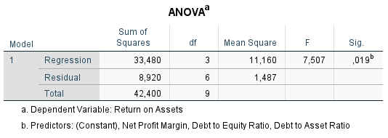
Figure 4. Result of Fcount using SPSS
Based on the F test results shown in the ANOVA table, the Fcount value is 7.507 with a significance value (Sig.) of 0.019. This significance value is smaller than the significance level α = 0.05 (0.019 < 0.05), which means that the regression model used is simultaneously significant. Consequently, it can be inferred that the independent variables, DER, DAR, NPM, jointly exert a significant influence on the dependent variable, ROA. This means that the combination of solvency ratios (DER and DAR) and profitability ratios (NPM) can explain the variation in changes in a company's ROA.
T Test
Figure 5. Result of Partial Test using SPSS
The T-test results in the coefficients table show that the DER has a T-value of 0.478 and a significance level (Sig.) of 0.649, which exceeds the 0.05 threshold. This demonstrates that DER does not significantly affect ROA, indicating that the proportion of total debt to equity does not substantially impact PT Telkom Indonesia Tbk’s ability to generate profits from its total assets during the research period.
Furthermore, the Debt to Asset Ratio (DAR) variable has a T-Value of -0.711 with a significance level of 0.504, which is also greater than 0.05. This indicates that DAR does not have a significant effect on ROA. In other words, the proportion of the debt to total assets ratio does not significantly impact the company’s return on assets.
In contrast, the Net Profit Margin (NPM) variable has a T-Value of 3.551 with a significance level of 0.012, which is less than 0.05. This indicates that NPM has a positive and significant effect on ROA, meaning that the higher the company’s net profit margin, the greater the return on its assets.
Discussion
Based on the results of the financial ratio analysis of PT Telkom Indonesia Tbk for the period 2015–2024, it can be seen that the Debt to Assets Ratio (DAR) and Debt to Equity Ratio (DER) are in the range of 41%–51% and 70%–104%. Meanwhile, the Return on Assets (ROA) and Net Profit Margin (NPM) ranged from 10% to 16% and 19% to 25%, respectively. These results indicate that over the past ten years, PT Telkom Indonesia Tbk's capital structure and profitability have been relatively stable, despite fluctuations in line with economic dynamics and the company's investment needs.
The increase in DAR and DER in 2020 indicates an increase in debt financing, possibly to strengthen operations and infrastructure investment amid economic pressures due to the COVID-19 pandemic. This condition led to an increase in interest expenses, which had an impact on the decline in ROA and NPM in the following years. However, after 2021, the DAR and DER values began to decline again, indicating that Telkom has successfully controlled its leverage ratio and balanced its capital structure so as not to put excessive pressure on profitability.
The F test results show an Fcount value of 7.507 with a significance value of 0.019 (< 0.05), which means that the Debt to Equity Ratio (DER), Debt to Asset Ratio (DAR), and Net Profit Margin (NPM) variables simultaneously have a significant effect on Return on Assets (ROA). This means that the combination of capital structure and profitability together can explain the variation in changes in the company's return on assets.
However, based on the t-test results, only Net Profit Margin (NPM) has a significant effect on ROA, with a t-value of 3.551 and Sig. 0.012 (< 0.05). Meanwhile, DER (t = 0.478; Sig. = 0.649) and DAR (t = -0.711; Sig. = 0.504) do not have a significant effect on ROA. This shows that profitability ratios that reflect profit efficiency are more dominant in influencing asset return rates than capital structure ratios.
From the results of the classical assumption test, the regression model has met the normality requirement, because the distribution of points on the Normal P–P Plot graph follows a relatively parallel diagonal line. The Durbin-Watson value of 1.376 indicates a slight positive autocorrelation, but it is still within acceptable limits so that the model remains valid for use. Meanwhile, the results of the multicollinearity test show that the DER and DAR variables have very small Tolerance values (0.018) and very high VIF (> 55), indicating high multicollinearity between the two solvency variables, while NPM does not experience multicollinearity.
Overall, it can be concluded that capital structure (DER and DAR) does not have a significant effect on profitability (ROA), while Net Profit Margin (NPM) has a positive and significant effect. This indicates that PT Telkom Indonesia Tbk's ability to increase profitability is more influenced by the company's net profit efficiency than by its funding policy or proportion of debt usage.
Conclusion
Based on the results of data analysis using SPSS regarding “Analysis of the Effect of Capital Structure (Solvency) on Profitability at PT Telkom Indonesia Tbk for the period 2015–2024,” several important conclusions can be drawn, as follows:
- The capital structure of PT Telkom Indonesia Tbk (DAR 41%–51%; DER 70%–104%) shows stable and healthy conditions, despite an increase in 2020 due to debt financing during the pandemic.
- The F test results show that DER, DAR, and NPM simultaneously have a significant effect on ROA (Fcount = 7.507; Sig. = 0.019), but partially only NPM has a significant effect (t = 3.551; Sig. = 0.012).
- Capital structure (DER and DAR) does not exert a statistically significant influence on profitability, while Net Profit Margin (NPM) has a positive and significant effect, so that the profitability of PT Telkom Indonesia Tbk is more influenced by net profit efficiency than debt usage policy.
Analysis of SPSS data for PT Telkom Indonesia Tbk from 2015 to 2024 reveals that the company’s profitability, measured by Return on Assets (ROA),is more significantly influenced by Net Income Management than by its capital structure. The findings show that capital structure indicators, namely Debt to Equity Ratio and Debt to Asset Ratio, do not sigfinificantly affect profitability. In contrast, NPM has a positive and meaningful impact on ROA. This implies that improvements in PT Telkom Indonesia Tbk’s profitability are primarily driven by effective net profit management and operational efficiency rather than by financing strategies or the level of debt within its capital framework.
Acknowledgments
The author would like to express sincere gratitude to Pamulang University, particularly the Faculty of Economics and Business, for the support and guidance provided throughout this research process. Appreciation is also extended to PT Telkom Indonesia Tbk for the availability of financial data that made this study possible.
References
PT Telkom Indonesia. (n.d.). Laporan [Webpage]. Retrieved October 31, 2025.
Smith, J. A., & Doe, R. (2020). Analisis struktur modal dan profitabilitas pada perusahaan telekomunikasi. Jurnal Bisnis dan Ekonomi Indonesia, 7(2), 123-145.
Sari, A. N., & Farhani, A. (2025). Pengaruh struktur modal terhadap profitabilitas pada perusahaan telekomunikasi. Jurnal Administrasi Publik dan Bisnis, 8(2), 1588-1602.
Anisa, Z. R., & Akbar, A. (2025). Pengaruh struktur modal, profitabilitas, dan ukuran perusahaan terhadap kinerja keuangan: Studi pada perusahaan terdaftar. Jurnal Manajemen, Akuntansi, Ekonomi, 4(2), 714-725.
Sa’adah, L., & Rustafi’ah, A. (2024). Kinerja keuangan pada PT Telekomunikasi Indonesia (Persero) Tbk periode 2019–2022. OPTIMAL: Jurnal Ekonomi dan Manajemen, 4(1), 268–279
Rismart, A. H. (2023). Analisis rasio profitabilitas untuk menilai kinerja keuangan pada PT Telkom Indonesia. EKALAYA: Jurnal Ekonomi Akuntansi, 1(4), 308–314.

